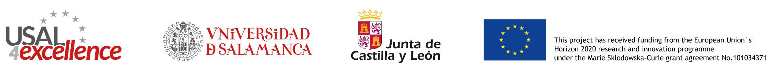

USAL4EXCELLENCE FELLOWSHIP PROGRAMME – 2nd CALL FOR APPLICATIONS 2022

APPEAL APPLICATION FORM
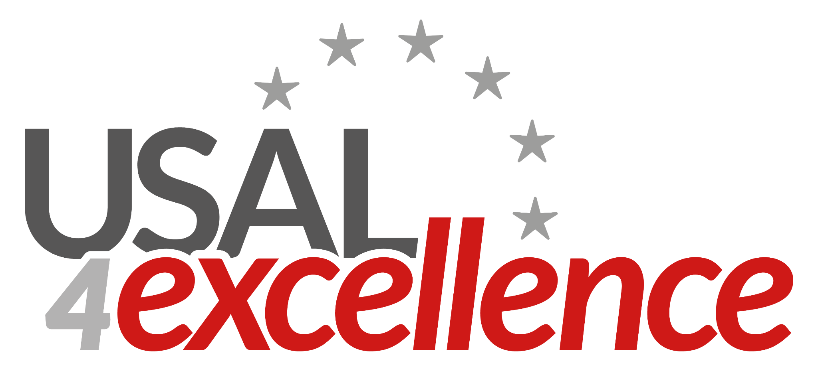

USAL4EXCELLENCE
University of Salamanca Programme to Foster Research Excellence

Marie Skɫodowska-Curie COFUND Actions

USAL4EXCELLENCE FELLOWSHIP PROGRAMME – 2nd CALL 2022
APPEAL APPLICATION FORM

It is mandatory to complete and submit the Appeal Application Form for the appeal to be considered. Once the Appeal Application Form has been properly completed, it must be signed by the applicant. This Form, together with all the corresponding documentation required to amend, must be submitted as a single PDF file or as a compressed file, such as RAR, Zip, etc., by email to usal4excellence@usal.es
Please tick the box indicating the corresponding cause of rejection that you wish to amend:

CAUSES OF REJECTED APPLICATIONS (AMENDABLE) |  | Appeal
R1 | Scanned copy of valid ID missing/not clear | ☐
R2 | Inadequate documentation clearly demonstrating that the applicant complies with the condition of being Experienced Researcher | ☐
R3 | Inadequate documentation clearly demonstrating that the application complies with the Mobility Rule.  Mobility Rule: applicants must demonstrate they have neither resided nor carried out their main activity (work, studies, etc.) in Spain for more than 12 months during the 3-year period between 16th December 2019 and 16th December 2022 (please detail dates of each period). | ☐
R4 | The scientific proposal has not been submitted or does not follow the mandatory provided template | ☐
R5 | The Letter of Commitment from the USAL supervisor has not been submitted or is not completed. Please note that the applicants must follow the Letter of Commitment template | ☐
R6 | The Letter of Commitment from the Partner Organization supervisor has not been submitted or is not completed. Please note that the applicants must follow the Letter of Commitment template | ☐
R7 | The Reference Letters have not been submitted | ☐
R8 | This application is not eligible because the candidate has submitted more than one application. Please note that only the first submission will be considered valid. | ☐
R9 | Selected Partner Organization for mandatory or voluntary secondment is not eligible based on call conditions | ☐
R10 | Other causes of rejection | ☐

You can also provide an additional explanation concerning any cause of rejection in the Comment section. Please note that this explanation does not exempt applicants from having to submit the required documents.

Comment section
1500 characters maximum with spaces

*Mandatory field
Name*:
Last name*:
Signature*:

Deadline: 7th July 2023, 23h:59min, CET time. Any appeal received after this deadline will not be accepted.

Please note that applicants are responsible for ensuring that the file is uploaded correctly and that the contents are legible. If the documents cannot be read properly, applicants will be unable to submit any further appeals.

